FOR IMMEDIATE RELEASE
Media Kit: https://winterkids.org/winter-games-media-kit/
Media Contacts:
Kristel Hayes, Marketing & Communications Manager
Email: khayes@winterkids.org
Phone: 207-871-5700 x 104
Marion Doyle, Education Director
Email: mdoyle@winterkids.org
Phone: 207-871-5700 x 103

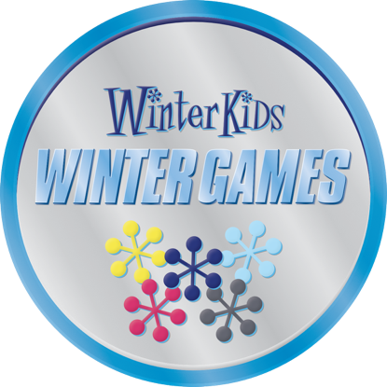

WinterKids Opens Registration for 2026 Winter Games Competitive Track
A Statewide Challenge for Schools That Moves, Inspires, and Unites Maine Kids
Westbrook, Maine — October 1, 2025 — WinterKids has officially opened registration for the 2026 Winter Games Competitive Track, a high-energy, four-week challenge that helps schools across Maine turn winter into a season of movement, learning, and community spirit. The theme of this year’s games is HEART!
Now in its ninth year, the Winter Games invite elementary schools across Maine to compete in weekly outdoor activities that combine physical education, nutrition, and winter wellness. Schools track participation, build momentum with creative themes, and showcase their team spirit—all while earning points and having fun outdoors.
“This program transforms the coldest months of the year into something kids look forward to,” says Marion Doyle, Education Director at WinterKids. “It’s not just about winning, it’s about building resilience, encouraging teamwork, and reminding every student that they belong outside.”
Participation Details

This January and February, 16 schools, one from each Maine county, will be selected to compete in the Competitive Track for cash prizes of up to $5,000.
Participation is free and includes:
- A Winter Games PLAYBook for each student with weekly themes and activity guides
- Weekly resources and incentives for each student meant to support their outdoor learning activities
- Cash prizes and gear for each school (up to $5,000 for the top winning school)
Who Can Register?
- Public elementary schools in Maine
- Priority given to Title I schools and rural districts
- Ideal for PE teachers, school nurses, and wellness teams looking to boost student engagement during winter
Timeline & Registration
Applications are open now at winterkids.org/winter-games. The deadline to apply is October 19, 2025.

About WinterKids
WinterKids helps children across Maine develop healthy lifelong habits through education and outdoor winter activity. Through inclusive, hands-on programming, we empower schools and families to make winter a season of connection, curiosity, and joy. Learn more at www.winterkids.org.

