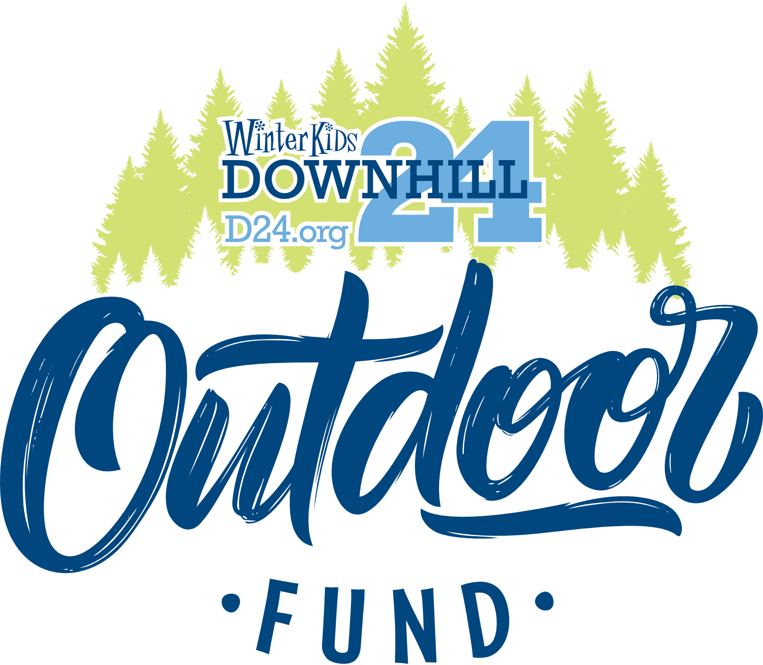

**JULY 2, 2024---FOR IMMEDIATE RELEASE**

**WinterKids Launches 2024 Community Vote for Outdoor Fund, Announces $25,000 in Statewide Grants**

**Media Contact:**

Josh Harrington,  Family Programs and Outreach Manager

[jharrington@winterkids.org](mailto:jharrington@winterkids.org)

**207.871.5700 x 104**

[**>> CLICK HERE to download full media kit**](https://winterkids.org/download/d24-outdoor-fund-media-kit-exp-12-31-24/?wpdmdl=153021&masterkey=6682d5e5b40c1)

*Westbrook, Maine -* WinterKids is excited to kick off the community vote for its annual Downhill 24 Outdoor Fund. Running from July 1 to July 31, residents across Maine can cast their votes for organizations dedicated to encouraging outdoor activities among children. This year’s fund will distribute $25,000 in grants to ten deserving organizations.

In its third consecutive year, the Downhill 24 Outdoor Fund will allocate grants to nine top-vote-getting entities—three public schools, three parks and recreation programs, and three nonprofit organizations throughout Maine. An additional honorable mention will also receive support. A diverse group of 47 organizations are vying for these funds.

"The community’s role is crucial," said Josh Harrington from WinterKids' Family Programs Outreach. "Maine is a large state, and engaging local voices ensures that our mission dovetails with the wants and needs of Mainers within their own communities."

To participate in this impactful initiative and vote for projects aiming to enhance outdoor opportunities for kids, visit [winterkids.org/downhill-24/outdoor-fund/.](https://winterkids.org/downhill-24/outdoor-fund/) Results will be announced in August with winners receiving portions of the $25K fund aimed at expanding their outdoor programs.

In conjunction with the grants available through the D24 Outdoor Fund, WinterKids is also allocating some money to directly fund learn to ski and snowboard experiences around Maine this winter. Our goal is to introduce over 250 kids to skiing and snowboarding through this initiative. These trips will be organized and lead by Maine youth groups with WinterKids providing some or all the needed funds.

For more information on how you can make a difference in promoting healthy lifestyles through outdoor engagement among Maine's youth:[**WinterKids.org**](https://winterkids.org/)**.**

**About WinterKids:** WinterKids is a nonprofit organization based in Maine that provides children with opportunities to stay active and healthy and learn outdoors during the winter months. Since its establishment in 1997, WinterKids has been dedicated to ensuring that hundreds of thousands of children embrace the joy of outdoor winter activities while reaping the numerous physical and mental health benefits they provide. To learn more, please visit [www.winterkids.org](http://www.winterkids.org).

WinterKids’ Major Community Sponsor is L.L. Bean. Supporting Sponsors are Agren, Central Maine Power, Harvard Pilgrim Health Care, WEX, Zachau Construction, and WMTW Channel 8 and The CW.