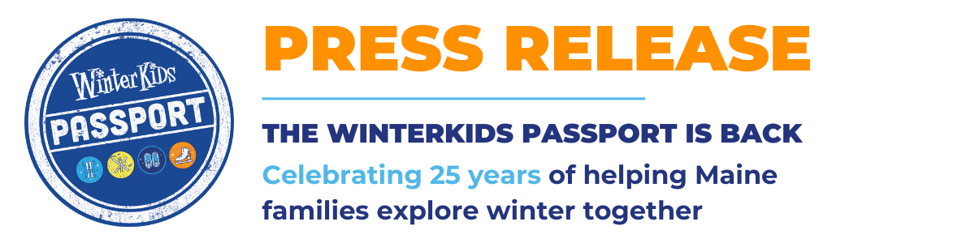

FOR IMMEDIATE RELEASE

The WinterKids Passport Is Back, Helping Maine Families Explore Winter Together
Family Memberships Now Open for 2025–2026 Season
Westbrook, Maine — WinterKids is thrilled to relaunch the WinterKids Passport, a beloved program that connects Maine families to free and discounted winter activities across the state.
The WinterKids Passport celebrates 25 years of helping families make winter active, affordable, and fun. With one membership, kids and their grown-ups can access free junior lift tickets, ice skating, gear rentals, XC Ski & snowshoe trails, and more at 75+ participating locations throughout Maine.
“The Passport is our way of opening the door to winter for every child and family,” says Josh Harrington, WinterKids Program Manager. “Whether you’re brand new to snow sports or a seasoned adventurer, the Passport gives families the freedom to get outside together all season long.”
What’s Included in the 2025–2026 WinterKids Passport:
- Free & discounted entry for kids ages 5–17 at more than 45 winter recreation partners across Maine (many offers valid with a paid adult ticket)
- Exclusive WinterKids Family Days with added savings and special experiences for Passport members with partners including Mt. Abram, Maine Mariners, Lost Valley, Midcoast Recreation, and much more
- Year-round access to deals and resources, including ways to find free family-friendly trails statewide
- A mobile-friendly format that makes it easy to explore offers and redeem on the go
- Opportunities to win prizes through the WinterKids Passport Photo Contest
Family memberships are just $40 per household and provide access for all eligible children through May 30, 2026.
How to Get Yours:
Visit www.winterkids.org/passport to purchase and activate your membership.
Give the gift of winter this holiday season - memberships also make great stocking stuffers!
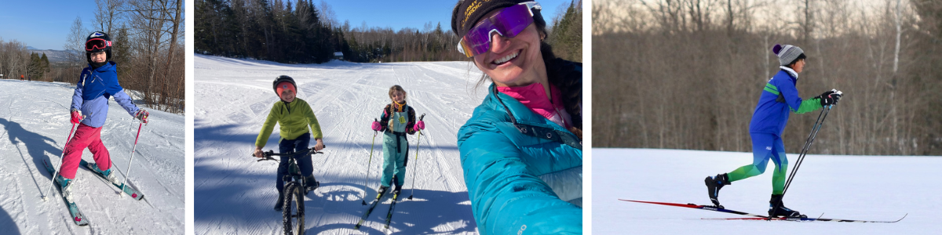

About WinterKids
WinterKids helps children develop healthy lifelong habits through education and fun outdoor winter activity. With programs for schools, families, and communities, WinterKids programs remove barriers to outdoor play and encourage kids across Maine to move, learn, and thrive in winter. Learn more at www.winterkids.org.
Media Contacts:
Kristel Hayes
Marketing & Communications Manager, WinterKids
khayes@winterkids.org
207-871-5700 x 104
Josh Harrington
Family Programs & Outreach Manager, WinterKids
jharrington@winterkids.org
(207) 256-9766
Website: www.winterkids.org/passport
Media Kit: winterkids.org/winterkids-passport-media-kit/

