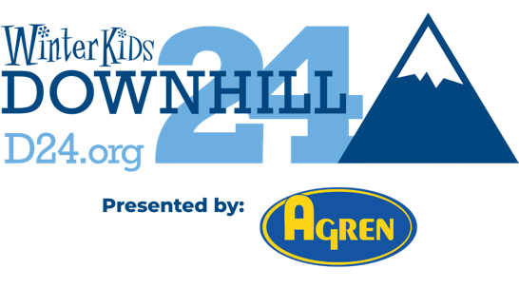
FOR IMMEDIATE RELEASE
Contact: Kristel Hayes, Marketing & Communications Manager
Email: khayes@winterkids.org
Phone: 207-871-5700 x 104
Website: D24.org
Media Kit: https://winterkids.org/downhill-24/media-kit/
Registration Now Open for the WinterKids Downhill 24
Maine’s only 24-Hour Ski Challenge Returns to Sugarloaf February 26-27, 2026
Westbrook, Maine — Registration is now open for the 14th Annual WinterKids Downhill 24, presented by Agren. Maine’s only 24-hour on snow team challenge returns to Sugarloaf on February 26 and 27, 2026. Participants of all ages are invited to ski, ride, or skin as part of a joyful celebration that supports outdoor play and learning for children across Maine.
The Downhill 24 brings together co-workers, friends, families, students, and community groups for a full night and day of movement and connection. Costumes music, and team spirit help create a fun, festival style atmosphere. Everyone chooses their own pace: one lap, many laps, sunrise laps, or cheering from the lodge. It all contributes to helping Maine kids thrive outdoors.
"Our crew has been part of the Downhill 24 for a long time, and it has been one of the highlights of our year,” says WinterKids board member, Joe LaJoie. “We have had so much fun out there together, and now our kids are stepping in with their own excitement and ideas. It makes me proud to see them take on the challenge and make it their own. This event brings out the best in people, and it feels good to share that energy with the next generation."
In 2025, the Downhill 24 community raised more than $770,000 for WinterKids programs. Those programs help schools and families across Maine access joyful winter experiences that nurture curiosity, confidence, and healthy habits for every child.
This year’s goal is $820,000 dollars.
Event Details
WinterKids Downhill 24
Date: Thursday, February 26 at 8 pm through Friday, February 27 at 8 pm
Location: Sugarloaf Mountain Resort
Who Can Join: Open to all ages and abilities. Youth under 18 participate with an adult.
Registration: www.winterkids.org/downhill24
Team spots are limited. Early registration is encouraged.
Team Options
Teams may include 1 to 12 participants.
- School Teams: Any Maine school may register for with a $3,000 fundraising commitment. Funds raised above that amount are shared equally with the school and WinterKids.
- Corporate Teams: Companies cover the team fee. Participants enjoy the event without additional fundraising commitments.
- Youth Fundraising Teams: Teams made up entirely of participants under 18. Participants on these teams commit to a fundraising minimum of $250.
- Mixed Ages Teams: Adult teams or adult and youth combinations. Adult participants on these teams commit to a fundraising minimum of $500.
- College Teams: Open to any college group interested in a unique 24-hour winter challenge with friends. Participants on these teams commit to a fundraising minimum of $500.
Ways to Join the Celebration
- Create or join a team
- Become an event sponsor
- Volunteer (volunteers receive a free lift pass, with additional bonus rewards for overnight shifts)
- Donate to support a participant or team
The WinterKids Downhill 24 is made possible through the generous support of Agren Appliance (Presenting Sponsor), Franklin Printing, Herc Rentals, Pike Industries, Patra, Portland Media Group, and WEX, along with our Community Partners, WMTW (Official Broadcast Partner), Central Maine Power, and L.L. Bean.
About WinterKids
WinterKids helps children across Maine build healthy lifelong habits through education and fun outdoor winter activity. Funds raised at the Downhill 24 support inclusive programs that remove barriers to outdoor activity and help schools and families enjoy winter with curiosity and confidence. Learn more at www.winterkids.org.

